Anglican Parish of St. Peter
Upper Gullies
Hickey’s Funeral Home Chapel
Funeral Service to Celebrate

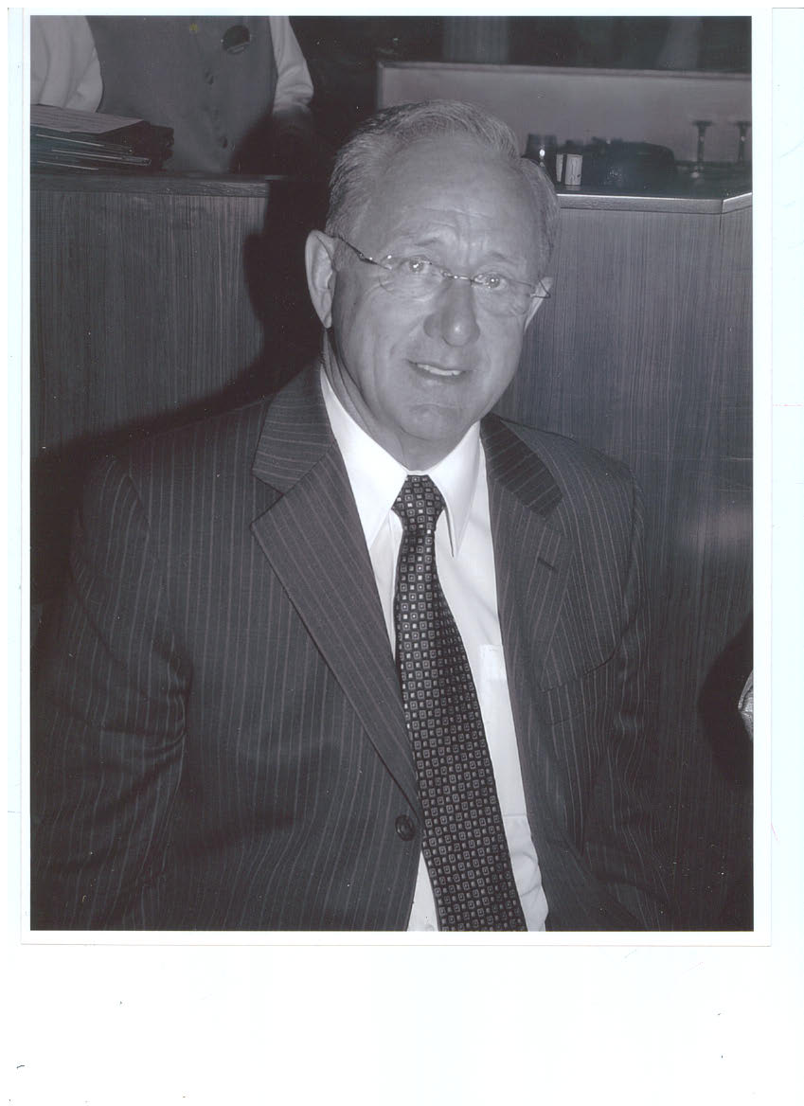

Clarence J. Morgan
April 18,1940 – November 28,2021
December 1, 2021

Officiant: The Rev‘d Wm. Strong
Musician: Darrin Martin
Order of Service
Taken From
Book of Alternative Services 1984

Welcome & Protocol Announcements
Address: Christine Hand
Song: Cliffs of Baccalieu by Jack Withers
Opening Sentences
Prayers & Collect
Hymn: Amazing Grace
First Reading. Isaiah 25.6-9 Nicole Hand
Psalm 23 Mark Vidal
Second Reading: James 2.14-18 Karley Morgan
Gospel Luke 10.25-37 Rev. Wm. Strong
Homily
Prayers
Response to each Petition “Hear Us Lord”
Leader Let us pray.

Lord’s Prayer
Our Father, who art in heaven, hallowed be thy name, thy kingdom come, thy will be done, on earth as it is in heaven. Give us this day our daily bread. And forgive us our trespasses, as we forgive those who trespass against us. And lead us not into temptation, but deliver us from evil. For thine is the kingdom, the power, and the glory, for ever and ever. Amen
Hymn: Away in A Manger

The Commendation
Give rest, O Christ, to your servants with your saints,
where sorrow and pain are no more,
neither sighing, but life everlasting.
You only are immortal, the creator and maker of all;
and we are mortal, formed of the earth, and to earth shall we return.
For so did you ordain when you created me, saying,
"You are dust, and to dust you shall return."
All of us go down to the dust;
yet even at the grave we make our song:
Alleluia, alleluia, alleluia.
Give rest, O Christ, to your servants with your saints,
where sorrow and pain are no more,
neither sighing, but life everlasting.

Commendation Prayers
Blessing
Response: Thanks Be to God

Nunc Dimittis
Lord now lettest thou thy servant depart in peace,/ according to thy word.
For mine eyes have seen thy salvation,/which thou hast prepared before the face of all people;
To be a light to lighten the Gentiles,/ and to be the glory of the people Israel.
Glory be to the father and to the son,/ and to the Holy Ghost ;
As it was in the beginning, is now, and ever shall be,/world without end. Amen.

Song: Take Me Back by Peter Jacobs

“Don’t disrupt your life for me”
By: Jonathan Hand

You wished
As your guard came to an end
Swept away by kind music and dreams
From this earthly place
To the next.

You believed that fear and failure were teachers
Sent for grander purpose
And yet, it was hard to see you afraid
As death walked toward you.

Today is the first day
Without you breathing beside me
Without you riddling to solve the shortcomings around us
Self-inflicted or otherwise
You are here somewhere though, Pop
In the rain or fog this Sunday
Over the sea, singing
In the snowy, windy barrens
Viewing the home you love
Talking with friends you’ve lost.

I feel the peace of your death washing on the rocks
Cleaning anxiety and regret from the shoulders of our family
And resting a weight upon my chest
Mine to hold now, with honour.

I asked God
To fill my eyes with your wisdom and foresight
Let me speak as you did, captivating and bullish
May my hands grow to hold the broom and shovel
You kept hidden under your bed.

I will make ground toward your sacred place
Where there is boundless security for others
Where men make the right decisions
And no work is left undone for the day.

I will bring us both there
Or I will meet you in heaven
Having done my best
To carry the torch you gave me.

Now, I turn to my trembling hands
Lost and unsure of themselves
As they realize they are partly yours
Partly shattered
And unable to piece together the past.

I hear your voice
And I dare not speak on your behalf
Having listened to your words for so long
I will listen a little longer.

