St. Peter’s Anglican Church
Did you know?

The first resident Clergyman in this area was a Missionary – Benjamin Fleet, who came to NL. in 1824 with two other ‘agents’ of Samuel Codner’s Nfld School Society. After teaching in St. John’s and several places in Trinity Bay, and acting as a lay-reader and catechist, he was ordained Priest in 1842 by Bishop Spencer. After serving 4 years in the Burin Mission he moved to Foxtrap and worked in this area, including our very own St. Peter’s, until he died in 1876. He had no permanent residence but ‘boarded around’. Rev. Fleet was in missionary work for 33 years and was no doubt a dedicated Christian and an interesting character. It is said that he ordered the men to sit on one side of the Nave and the women on the other. The Reverend Benjamin Fleet is interred in St. Peter’s Cemetery, Upper Gullies behind the Church on the west side. It is said that Rev. Fleet requested burial at St. Peter’s because it was the only Anglican cemetery on the South Shore to be completely fenced and he didn’t want roaming horses, cows and goats grazing on his grave.

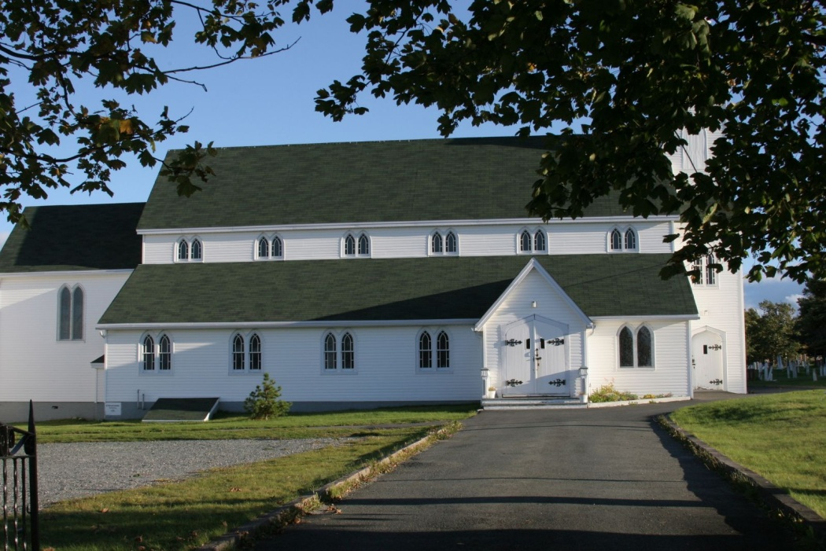

Worship Service Today
8:30 AM and 10:30 AM
ON DUTY | Today:  April 23, 2017 |  | Next Sunday:  April 30, 2017
 | 8:30 AM | 10:30 AM | 8:30 AM | 10:30 AM
Sides-  Persons: | D. Morgan  A. Lemoine | D. Pretty  N. Andrews  G. Halley  M. Anthony  C. Button | D. Bishop, W. Bishop | K. Pack  G. Pack  K. Scott  B. Scott  A. Spracklin  D. Scott R. Hilliard
Eucharist Assistant | Dennis Morgan | Keith Pack
Servers’ Guild: |  | Darcy Scott
Altar Guild | Cynthia D, Carol K, Betty H, Pat P, Mary A. |  | Barbara E, Carmel H, Karen W, Betty M, Elaine M.
ACW Spring Sale
The ACW Spring Sale will be held on April 29th, beginning at 10:00 AM, with morning coffee, and sale of goods. Roast beef dinner at 6 PM, followed by a card game. Reserve your tickets by calling the Church office at 744-2648. Tickets to b e paid at the door. Deadline, April 25th.

Parish Breakfast
St. Peter’s will be hosting a parish breakfast on Sunday, May 7th at 9:15 AM. This hardy breakfast will consist of Scrambled Eggs, Bologna, Toast, Juice, Tea/Coffee and cereal for the kids. Only $7.00 for adults and $2.00 for children. Please jot down your name and number of attendees on the form at the back of the Church to give us an idea of how many to expect.

Yoga at St. Peter’s- BEGINNING THIS TUESDAY. We are pleased to announce this new program in our parish. Join us for an evening of relaxation. Come and give yourself the gift of yoga in our beautiful 112 year old church on the hill in Upper Gullies. Yoga will be offered from 7:30-8:30 pm on Tuesdays from April 25-May 16. The early registration will be $30 for 4 sessions. Or you can drop in at a fee of $10 per session. By pre-registering you also get the opportunity to bring a friend to one
of the sessions. You may pre-register by contacting St. Peter’s Church at 744-2648, any morning. Pre-registration will also take place in person at 7:15 pm on the first night, April 25. Calling the church to pre-register is encouraged, as space may be limited. Please bring along a mat, a water bottle, a towel or light blanket, and dress in layers. These yoga sessions will be appropriate for people of all levels. Beginners are welcome. We look forward to seeing you at yoga in the peaceful and inspiring atmosphere of St. Peter’s.

Sunday of Song

Sunday of Song—Join vocalist Michelle Noftall and renowned musicians Craig Young and Sandy Morris for an afternoon of folk, country and gospel favourites (and a sneak peak of music from Michelle’s upcoming album, ‘Roots in the Water’), Sunday, June 4th, 3:00 PM, St. Peter’s Anglican Church, Upper Gullies. Tickets $15 in advance, $20 at the door.

St. Peter’s Church Library
We are excited to begin a new Ministry at St. Peter’s that we hope will benefit both young and old. We will enjoy the benefits of a lending library in our own church. It will be housed in the vestry of our church, available for all to access. We will be looking for your help in starting this literary adventure. If you have any gently used books that are fairly current and are willing to donate we would greatly appreciate it. Or if you are shopping and see a great book feel free to buy and donate to this great ministry. We are looking for topics such as: inspirational, self-help, mindfulness, grieving/loss, addictions, healthful living, family relationships, parenting, recipe books, and joyful books. These can be adult or children’s books. Any books or donations may be dropped at the parish office. If you wish any further information please contact Colleen Reid 240-1209 or colleenreid@nlesd.ca We look forward to sharing and reading at St. Peter’s.

Annual Meeting will be held in the Parish Hall at 3 PM today.
Living Well With Advanced Cancer: Are you living with cancer? Eastern Health invites you to attend a 8-week interactive support group designed to help those living with advanced cancer to reconnect with and sustain meaning in their lives. Co-facilitated by the Social Work Department of the Dr. H. Bliss Murphy Cancer Centre and the Pastoral Care and Ethics Department of Eastern Health, this program will start May 8th and will meet on Monday’s from 2-4 p.m. until June 26th at the Botanical Garden Field Centre, 306 Mount Scio Road (weeks 2, 3, and 7 will meet Tuesday afternoon). For more information or to register please contact Paul Grimes at 777-7611 or Bill Haynes at 777-7990.

Pastoral/Spiritual Care
Pastoral/Spiritual Care is available to all who enter an Eastern Health facility. To avail of this ministry of the church, upon admission, you (or your next of kin) will be asked if you would like to receive pastoral care. If you answer ‘yes’ and state your denomination you will be added to the list of patients to be visited by the chaplain and/or pastoral visitor. If you answer ‘no’ your choice will be respected and you will not receive a pastoral visit. Should you later change your mind please advise the nurse or the Pastoral Care office at 777-6959. Chaplains are bound by the Protection of Information Act. Chaplains can only advise your parish clergy of your admission with your consent.
Faith in the Public Square
Faith in the Public Square is a conference to be hosted by the Anglican Diocese of Eastern Newfoundland and Labrador on Saturday, June 3, 2017. This conference will look at the contribution of faith communities to the wider social fabric of our province. Bishop Peddle will be chairing the gathering and giving a short opening talk. Speakers will include Sister Elizabeth Davis, member of the Sisters of Mercy, CEO of Eastern Health, and recipient of the Order of Canada, and the Right Honourable Adrienne Clarkson, the 26th Governor General of Canada. With invitations extended to members of Christian, Jewish, Muslim, Hindu, Sikh and Buddhist communities along with other community partners and representatives of municipal, provincial and federal levels of government, the conference will explore the place of faith in Newfoundland and Labrador and examine the ways in which faith is expressed outside the places of worship. The conference will run from 10 a.m. until 4 p.m. on Saturday, June 3. For further information and to register, please contact the Reverend Christopher Fowler at 689-6697 or by email: cfowler@anglicannl.net
Spousal Grief and Bereavement Support Group – Are you experiencing grief due `to the death of your spouse? Please join us on Tuesday nights, 7:00-8:30 pm at St. Peter’s Parish Hall. This support group provides an opportunity for individuals to meet and discuss the loss of your spouse; provide support to each other; and share information that may help during the grieving process. This support group is ‘drop in’ and supported by Grief and Bereavement Services, Eastern Health. For more information, please call 631-9539 or 777-8972.
A donation to the building fund has been made in loving memory of:
Karen Corbett (remembering her birthday on April 23), by Mom and Dad and Edith Bishop (remembering her birthday on April 24), by brother Calvin Butler

